Uniquely Jesus December 4, 2016
Mark 8:1-26

Read verses 1-8.
During those days, another large crowd gathered. Since they had nothing to eat, Jesus called his disciples to him and said, 2 “I have compassion for these people; they have already been with me three days and have nothing to eat. 3 If I send them home hungry, they will collapse on the way, because some of them have come a long distance.” 4 His disciples answered, “But where in this remote place can anyone get enough bread to feed them?” 5 “How many loaves do you have?” Jesus asked. “Seven,” they replied. 6 He told the crowd to sit down on the ground.
When he had taken the seven loaves and given thanks, he broke them and gave them to his disciples to distribute to the people, and they did so. 7 They had a few small fish as well; he gave thanks for them also and told the disciples to distribute them. 8 The people ate and were satisfied. Afterward the disciples picked up seven basketfuls of broken pieces that were left over. 9 About four thousand were present. After he had sent them away, 10 he got into the boat with his disciples and went to the region of Dalmanutha.

This passage sounds remarkably similar to what happened in Mark 6.
Some skeptics argue there was actually only one feeding ‘miracle’ and that over time,
in the oral retelling of this story, somehow, it morphed into two separate feedings.

As you go to our coffee time, here’s the question.
Is this miracle the same one that happened in Mark 6?
What in the Mark 8 passage supports your answer?

Similarities
- a large crowd
- a hungry crowd
- a remote location
- disciples searched for available food
- disciples found enough food for only a few people
- the crowd was told to sit
- Jesus prayed and multiplied the food
- the disciples served the food
- everyone was satisfied
- there was lots of left-overs

Differences
- location: the Decapolis vs. the Galilee
- 4000 men vs. 5000 men
- three days with Jesus vs. one day
- seven loaves found vs. five
- two prayers vs. one
- seven baskets of leftovers vs. twelve
- the crowd sat down vs. sitting down in groups of 100 and 50
- no mention of what season vs. it was springtime in the Galilee

There is one other important indicator that decisively settles the question.
Look at Mark 8:19-20.
Context: Jesus was speaking to his followers, as they crossed the lake.
How many miraculous feedings did Jesus speak of? Two!

Where did the second miracle of feeding happen? Back up to Mark 7:31.
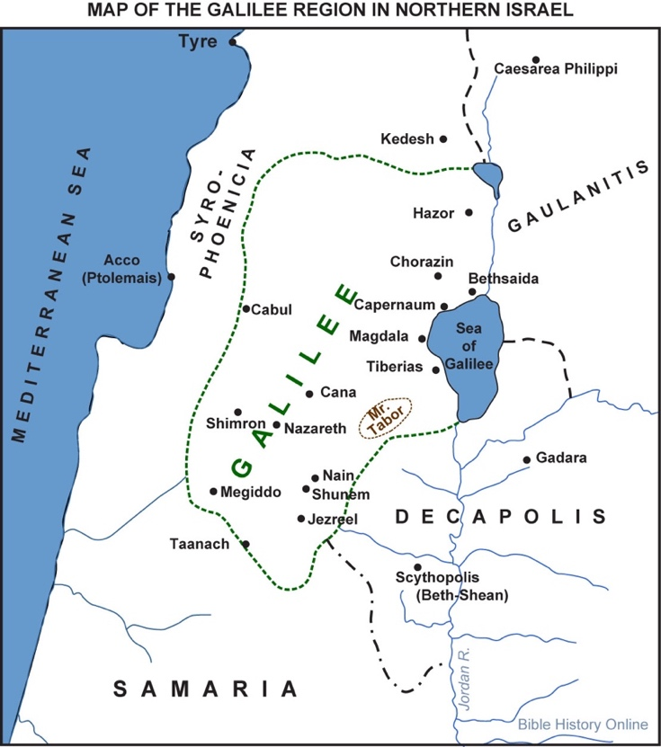
The Decapolis is where Jesus had healed the man called “Legion.”
And when that man begged to go with Jesus, Jesus told him, “Go home to your family
and tell them how much the Lord has done for you, and how he has had mercy on you.” Mark 5:19

Unlike previously, when the people of that region had “plead[ed] with Jesus to leave,” this time, 8:1, a large crowd gathered to hear Jesus and to be with him.

Don’t you wonder, to what extent, had the testimony of that one man helped to influence the obvious change in people’s attitude towards Jesus?

Phoenicia and the Decapolis were inhabited predominantly by Gentiles, though there were Jews who lived there.
Why did Jesus go to these Gentile regions when, in his own words, his ministry was primarily focused on the nation of Israel?

He did so because...God’s heart has always been to rescue the nations of the world.

Psalm 67:2-3: “...that your ways may be known on earth, your salvation among all nations. May the peoples praise you, God; may all the peoples praise you. May the nations be glad and sing for joy, for you rule the peoples with equity and guide the nations of the earth.”

In going up to Phoenicia and then over to the Decapolis, Jesus demonstrated what he had told Nicodemus in John 3:16 – God loves the world.

So, in this miracle of multiplying food, was there a deeper significance Jesus was wanting to emphasize to his followers? I think there was.

After the first feeding, Jesus said to a group of people who came to him the next day, looking for another free meal, John 6:35: “I am the bread of life. The one who comes to me will never go hungry, and the one who believes in me will never be thirsty.”

* I believe that through these two miracles, Jesus communicated to both Jew and Gentile, that he, the “bread of life,” is available for any and all, who come to him, regardless of a person’s nationality, ethnicity, gender, social standing, etc.

Jesus miraculously satisfied people’s physical hunger, to show that he can satisfy the hunger of the human soul.

There are two additional things in this miracle, I want to point out to you.
1. It’s pretty hard not to miss that the disciples were slow on the uptake.
Jesus voiced his desire to feed the crowd and the disciples asked: “Where would we get enough bread to feed so many people?”

It makes you wish you could ask them: “The scenario didn’t feel at all familiar?
You’d never faced anything remotely similar?
But there is no hint that Jesus was frustrated with them.
Nothing to suggest he rolled his eyes or quietly muttered under his breath, “Are you kidding me???”

Don’t the disciples sound so familiar? Don’t they remind us of ourselves??

How Jesus was with them, is how he is with us.
When we are slow to remember, he patiently walks us through it…again, and again.
Because he loves us, he is committed to finish in us what he began (Philippians 1:6).

Nothing can separate us from his love.
Romans 8 adds a number of qualifiers - neither death nor life, angels nor demons,
the present nor the future.
I would add – neither our slowness to understand nor our forgetfulness in remembering, can separate us from God’s love.

Experiencing Jesus’ patience, goodness and love, prompts within us a response of gratitude. And in turn, it is gratitude which fuels our worship - privately throughout the week; and corporately when we come together on Sundays.

2. In both feedings, Jesus involved his followers.
Could he have done it all himself?
Of course he could have.
But did he? No!
It is always Jesus’ will to involve his followers in what he does.

Fast forward 2000 years.
Jesus still has compassion on people; he still cares about a person’s practical needs.
And it is still his will to involve us, his followers, in his works of compassion.
Hands and feet.
Jesus intends that needy people would experience his goodness; his concern; his help... through us.

As we act in Jesus’ name, Tom Wright says:
“Of course our resources will seem, and feel, totally inadequate. That is Jesus’ problem, not ours. The two “feeding stories” indicate well enough that Jesus will cope with it. Our task...is not to bemoan how few “loaves and fishes” we have for the crowd, but to offer them to Jesus, to do whatever he wants with them, and then to be ready to distribute them at this command.” Mark for Everyone, p.102.

After feeding the large crowd, Jesus left the Decapolis and went across the lake to the region of Dalmanutha.
v.11-21.
This is the seventh time, Mark writes of the Pharisees coming to Jesus.
And like before, they came to question; to test him.
This time they wanted Jesus to give them “a sign from heaven.”
What was that about?
The Pharisees had heard the whispers.
People were wondering, “Is Jesus the Messiah?”
So, with this request, the Pharisees hoped to force Jesus’ hand, and expose him as the fraud they believed him to be.

When the Messiah came, the Pharisees believed he would decisively overthrow the nations that had occupied and crushed Israel. Look at Joel 3:9-21.

An on-line commentary on Gracepoint Berkeley Church’s website says,
“[The Pharisees] asked Jesus to do something that would signal Israel’s deliverance from her enemies... A sign from heaven was something that would be ‘apocalyptic…’ like ‘the mighty deeds of deliverance’ God had done in the past when he rescued Israel from Egypt.”

“But the miracle of multiplying food pointed to the blessing, not the destruction of Gentiles. Jesus refused to give the Pharisees a “sign from heaven” because God had sent him, not to smash Israel’s enemies, but to give his life in sacrifice for all of humanity…” gracepointdevotions.org

Before answering the Pharisees, look again at what Jesus did – v.12.
“He sighed deeply.”
Before Jesus healed the man who was deaf and could hardly talk, (see 7:34), he had also sighed deeply. What did it mean when Jesus did this?

The man’s physical brokenness grieved Jesus. I think Jesus’ groan expressed the dismay of God at the physical harm sin had caused: “This is not what we had intended when we created.”

And when Jesus deeply sighed before answering the Pharisees, I think he expressed God’s dismay at the spiritual death of the human soul, as evidenced in the Pharisees hardness of heart.

It is a common question to wonder if God cares about the brokenness of this world.
Jesus’ sigh tells us he does.
It is also a common question to wonder why God doesn’t do something if he really does care. In Jesus, he did.

There is yet another groan that would be expressed by Jesus - his cry from the cross.
Jesus’ willingness to hang on the cross is God’s response to what is wrong in this world. It shows how God intends to undo what sin and death ruined.

That day in Dalmanutha, the Pharisees who had come, hoping to trap Jesus, did not succeed in forcing Jesus’ hand, nor adjust God’s timetable to fit theirs.
Jesus said, “No,” to their request, and then climbed into a waiting boat to go in search of people who were waiting for him.

I don’t want to force the application here.
But that little phrase, “he left them,” jumped off the page at me.
If a person says no to Jesus repeatedly, at some point Jesus will “leave them alone.”

What we see in this conflict between Jesus and the Pharisees is a clash of kingdom-visions. Jesus’ teaching and his miracles were “signs” proving that the kingdom of God had come near.
But the kingdom Jesus announced was proving to be radically different from what the Pharisees thought it should be, and what Herod hoped it would be.

Herod wanted to be the King of the Jews.
And the Pharisees wanted to be the one to run the kingdom of God.
And both were so far off the mark.

This is why Jesus said to his disciples as they crossed the lake, going from Dalmanutha to Bethsaida: “Be careful. Watch out for the yeast of the Pharisees and that of Herod.”

The disciples thought Jesus said this to them because they had forgotten to bring bread. There had been seven large baskets of left-overs, and not one of them thought to bring some of it along. But that was not the point Jesus was wanting to make.

Example of white water rafting on the Illecillewaet River.
The first part of the trip was calm; smooth.
But then we came around a bend in the river, and there was this wall of water ahead.
There was still time to bail, I think.
But our guide had no intent of doing so.
Instead, he called out instructions, reminding us, hold your paddles firm; place your feet in the footholds; now dig deep, paddle hard; hold on.

We were at the point in the adventure where we were committed to ride the white water.

Jesus knew that he had reached that point in his public ministry where there was no going back. He had prepared for this his whole life. And those last few years, he had been preparing his disciples.

But he knew they would never last, if they only considered him to be a teacher; a healer; a prophet; he knew they would flounder and drown if the Pharisees teaching and Herod’s attitude took hold in them.

The fact that Jesus asked tough questions of his followers, shows what it looks like when God is committed to finish in a person what he’s started.
He pushed them to think, and to think deeply.
He does the same with us, as he did with them.

Do you still not see or understand?
Are your hearts hardened?
Do you have eyes, but fail to see, and ears, but fail to hear?
Don’t you remember?

It is by grace we are saved through faith. (Ephesians 2:8-9)
But it is by the renewing of our mind that we are transformed. (Romans 12:2)

Those men had put their faith in Jesus.
But their minds needed renewing.
Jesus would in the days ahead, continue to teach them God’s word; to help them grow in wisdom and understanding, so they would be firmly grounded, and not moved when opposition came against them, as it would.

This grounding in God’s word was a lifelong process.
His last night with them, Jesus said: “I have much more to say to you, more than you can now bear. But when he, the Spirit of truth comes, he will guide you into all the truth. He will not speak on his own; he will speak only what he hears, and he will tell you what it yet to come. He will glorify me because it is from me that he will receive what he will make known to you.” John 16:12-14

It is no different for you and I.
The same Holy Spirit has been given to guide us into the truth.
He takes what he receives from Jesus and he makes it known to us.
You open this book (the Bible) and you are in place for Jesus to speak to you.

I don’t think Jesus would say to us today, “Be careful of the yeast of the Pharisees and that of Herod.”
But he would warn us of the skepticism that permeates the culture we live in.
He would tell us to be careful for it would suffocate our faith.

He would warn us of the narcissistic spirit that inspires the mindset of our time:
To your own self be true.
Jesus calls you and I to lay our lives down at his feet, for it is only when our lives are God-focused, instead of self-focused, that we really live life to the full.

Francis Chan said: There is no greater failure than to have success in the things that don’t matter in eternity.
Jesus said, “What good will it be for someone to gain the whole world, yet forfeit their soul?” Matthew 16:26

Jesus calls his followers to spend their lives on what matters - his kingdom and his mission.

To that end, he first patiently pursues us, inviting us to welcome him into our lives.
Then he graciously trains, teaches and when necessary, asks the tough questions, challenging us to keep on putting off the old and putting on the new; to work out our salvation, as God works in us.

What an amazing Savior!
Isaiah 53

The Table

Life Group Discussion Questions
Mark 8:1-26

Icebreaker: How did your parents complete this sentence when you were a child or a teen: “How many times do I have to tell you...”

Tom Wright says:
“Of course our resources will seem, and feel, totally inadequate. That is Jesus’ problem, not ours. The two “feeding stories” indicate well enough that Jesus will cope with it. Our task...is not to bemoan how few “loaves and fishes” we have for the crowd, but to offer them to Jesus, to do whatever he wants with them, and then to be ready to distribute them at this command.” Mark for Everyone, p.102.

Respond and interact with this statement. Do you agree/disagree? Why? Why not?
Are there specific situations where this would apply to us?

Why do people demand signs of God?
Why do you think a sign might convince a person? not convince a person?
What does Jesus’ refusal to give a sign say about how he may respond to people today?

The warning of the yeast of the Pharisees and that of Herod.
See also Matthew 16:5-12.
What does Matthew add to our understanding of the point Jesus is making?
With what tone of voice do you hear Jesus speaking in verses 17-21?

How does false teaching take hold in a person?
Try to identify the specific means.
Is there any similarity to the process of temptation? See James 1:13-15.

What do we learn about Jesus by his refusal to give the Pharisees a sign and his challenging of the disciples for their spiritual dullness?
Are there other incidents which show this characteristic in Jesus?

What is difficult for you to “remember” about Jesus; or your walk of faith; or how you live in this world?
What one thing has Jesus done for you that is super important for you to remember?

What is different about the healing of Mark 8:22-26?
Do you think Mark intends for us to draw a greater significance to this miracle because of where he has placed it in the greater story? Why? Why not?

Take note of what happened before the miracle and after.
What might this miracle be illustrating?

What came easy for you in following Jesus?
What areas/things/truths are still difficult for you to understand or to act on?

