Why God Rocks Our World August 11, 2019
Acts 11:1-18



This past month I’ve reconnected with my family’s anabaptist roots, appreciating my heritage and being challenged to by those who lived before me, to be found faithful to Jesus.

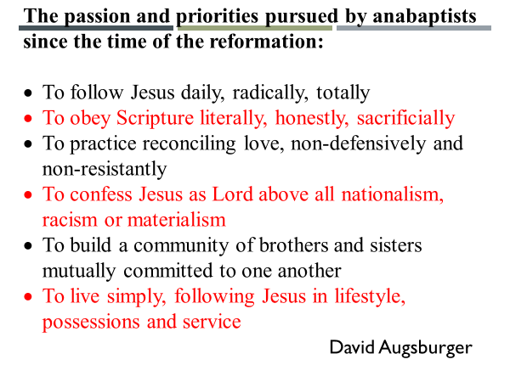

These priorities which come from the life and practice of Jesus as recorded in the gospels, were embodied by the early church.

Read Acts 11:1-18.
Acts 11 is remarkably similar to Acts 10.
Why do you think the Holy Spirit led Dr. Luke to do this?

Let me read verse 1 again.
You might not have felt the room move when I read verse 1.
But this was not the case for Dr. Luke’s original audience.
In Acts 8, when the Samaritans accepted the word of God it was shocking news.
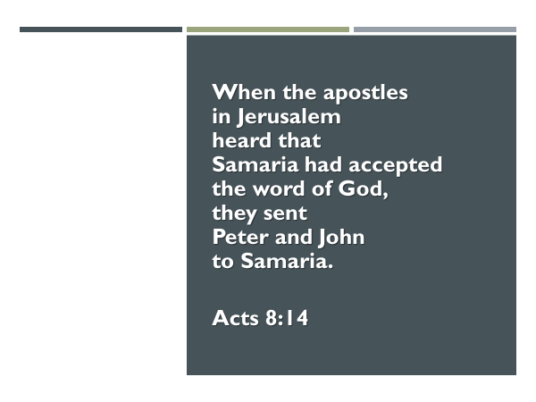
And then, when it was heard throughout Judea that the Gentiles had also received the word of God …the Jewish world of that day was rocked.

There had been Gentiles, that is non-Jews, before Caesarea, who had believed in Yahweh, and lived by his word.
But until Jesus came to the earth, God’s dealings with mankind had been primarily focused on… the family of Abraham.

Jesus’ final instructions to his followers were…go into all the world.
But whatever their reasons…they had stayed in Jerusalem.
From Jesus we learn, as did they, that… the heart of God is for all peoples of this world.

The vision of Revelation 7:9

This is why God had pushed his people out of Jerusalem and why the LORD had so dramatically intervened in Peter’s life as told in Acts 10-11.

Jesus came to the earth, not just to be the Messiah of the Jewish people.
He came as the Rescuer… of the world.

The scripture says in the gospel of John, 3:16, “For God so loved the world that he gave his one and only Son, that whoever believes in him, should not perish but have everlasting life.”

In John 3:16, the word “world” qualifies the word “whoever.”
Anyone… in the world… who believes in Jesus… will not perish but have everlasting life.

In the person of Jesus we learn that God is not content to leave humanity under the power of the devil.
In every generation, Jesus is not ok with the spiritual status quo.
He is the searching Savior.

Do you know how we know that?
Because of what Peter told Cornelius.
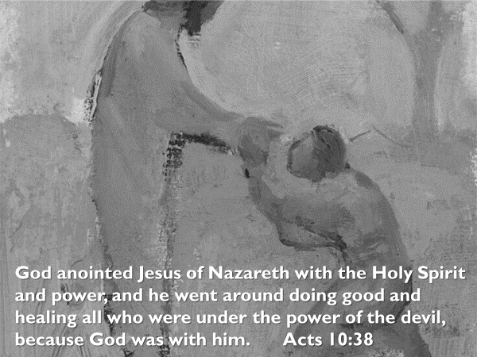

What God did through Jesus; Jesus now does through his followers.
He anoints them with the same Holy Spirit and with power from heaven.
But not so that they might have a cool, private spiritual experience.

We are anointed in order that… the good things done through us in the name and power of Jesus…would point people to our good, good Father, and result in them being freed from the power of the devil.

We earlier sang – “Lay me Down.”
We declared in that song – “your will, your way, always.”

This is the passion that has shaped the priorities of Jesus’ followers – we love and live for him with all of our heart, soul and mind.

Let’s recap from our text the specifics of how Peter pursued God’s will, Jesus’ way, always.

- We see in Acts 10; 11:12 how Peter so radically followed Jesus… that he would go to the home of a Gentile.

Why did Peter move in step with God?
Because… he considered Jesus to be worthy.
Is this not what compels the follower of Jesus to spend their life on him?
Is this not what changes the orientation of our life from “what’s best for me” to what “honors Jesus?”

Believer…does radical…describe how you follow Jesus?

- We see in Acts 11:5-10 how Peter obeyed the word of the LORD even when doing so proved costly to him.

When it came to a choice whether he would trust his own instinct – stay in Joppa - or the word of the LORD – have no hesitation to go with these men - Peter chose the Lord’s word.

Believer…does sacrificial describe how you obey the Scripture?

- Peter practiced reconciling love – both towards Cornelius…a man whom the Jewish law said he couldn’t associate with – and then towards those who criticized him for going into the home of Cornelius.

Why did Peter do so?
He practiced reconciling love because he himself had experienced the reconciling love of God. See John 21.

Peter wrote of this in his first epistle, 1:22-23.

Love not only resolves a conflict; love covers a multitude of sin; love reconciles a broken relationship.

Parable in Matthew 18:21-35.

Believer…are you practicing reconciling love or are you nursing an offense?

- Peter confessed Jesus as Lord… even when it brought him into conflict with the long-standing spiritual practices of his own nation – 11:3.

Peter’s rationale?
11:17 - “How could I stand in God’s way?”
Peter chose to stand with Jesus, and to stand under the authority of Jesus… no matter what.

Believer…who really is in charge of your life – you or Jesus?
Believer…does Jesus have full authority over you? If he doesn’t, he isn’t your Lord.

- We see Peter in this passage, helping to build the church of Jesus, the community of fellow brothers and sisters, who together lived for the glory of Jesus – see 11:4.

The result? 11:18 – they glorified God, praising him for what he had done in granting repentance to Gentiles.

Believer…do you just attend church or are you actively building this faith community by using your gifts in service to others?

- Lastly, we see in this passage the simplicity of Peter’s service and his way of life.

Not that long ago, he had healed Aeneas… a man paralyzed for eight years.
Then he had raised Dorcas from the dead.
Then he had preached to a large number of people who were eager to hear, (v.14), a message through which they could be saved.

And yet, when Peter came back to Jerusalem and was criticized, he patiently and simply told the story of what God had done

Believer… does simplicity and humility grace your life and service for Jesus?

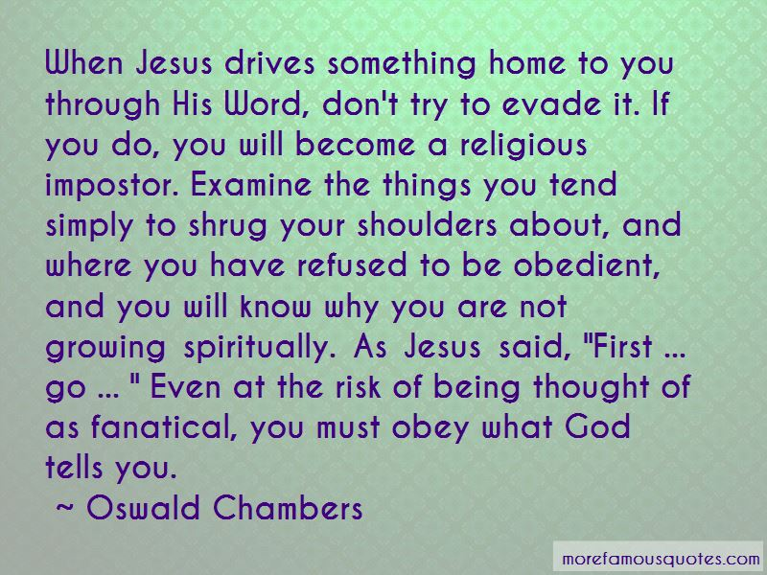

Holy Spirit we welcome you to ask these questions of us.
Speak Lord…we are listening as your Spirit would apply the truth of your word to our souls.

The Blessing (Challenge)
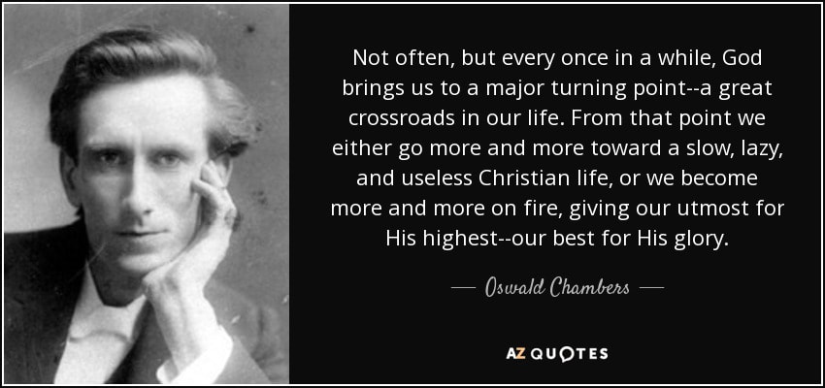

It’s why he took the time to carefully tell the whole story to his critics.

– daily, radically and totally.

But there is a second reason given in v.2-3.

When Jesus began his public ministry he clearly stated:

The good news which Jesus preached was welcomed by many.

But the gospels are also clear that Jesus encountered opposition because of his insistence that some of Israel’s spiritual practices were now rendered obsolete.

Jesus knew this would be challenging for the religious leaders, which is way in the early days of his ministry he spoke this parable.
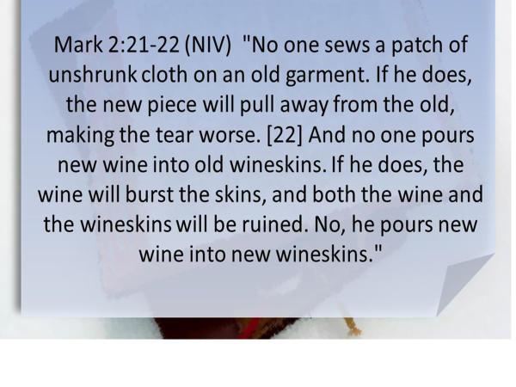
This parable was very much applicable to the situation that faced Peter when he criticism being leveled against Peter.
The gospel of Jesus couldn’t fit into the old wineskins of Judaism, particularly the wineskin of non-association.

In the early days of his ministry Jesus had spoken of the challenge that his coming would
Jesus also had spoken to his followers

Did Dr. Luke want to emphasize the different ways God communicated when the only copies of the Scripture were to be found in the synagogues?
- Through a vision
- Through a voice from heaven
- Through the Holy Spirit
- Through an angel

Or was it to emphasize that the dietary laws of the OT era had served their purpose and were no longer needed, just as the Sabbath, the Temple and the sacrifices were no longer needed since Jesus had come?

In the case of the dietary laws, Jesus himself had declared all foods clean in Mark 7:17-19.
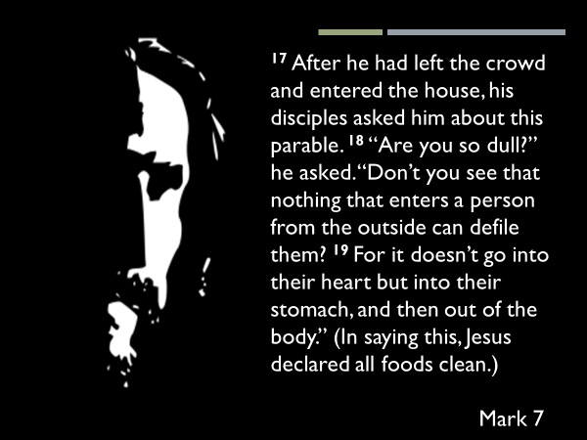

Or did Dr. Luke want to impress upon the reader the critical necessity of the baptism of the Holy Spirit who is given to all who place their faith in Jesus?

Or was it to give to the reader a workable way to deal with offense?

These are all truth themes you could pull from this chapter.
But Dr. Luke himself in verse 1 tells us why he restated the events that happened at Caesarea.
It was because – …the Gentiles… received the word of God.
But there is another reason – Luke emphasized for the reader the power of the gospel of Jesus to save.
He didn’t want his readers to miss this, or to breeze over it.

Look at what Paul wrote to the church at Ephesus about the power of Jesus’ gospel.


Paul here is speaking of Jesus.
He says that Jesus is our peace.
He announces to the reader that peace is not a feeling, nor is it a state of mind.
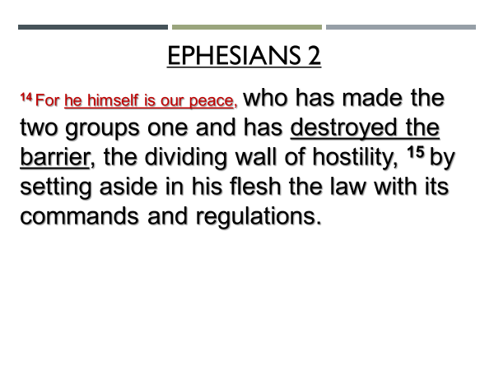
What did Jesus do?
Paul says that he made the two groups one.
Who are the two groups he refers to?
They are Jews and Gentiles.

How did Jesus make the two groups one?
He “destroyed” the barrier that had divided.
This word “destroy” means to break; to loosen the force of something; to render something impotent.
The same word is used in 1 John 3:8.
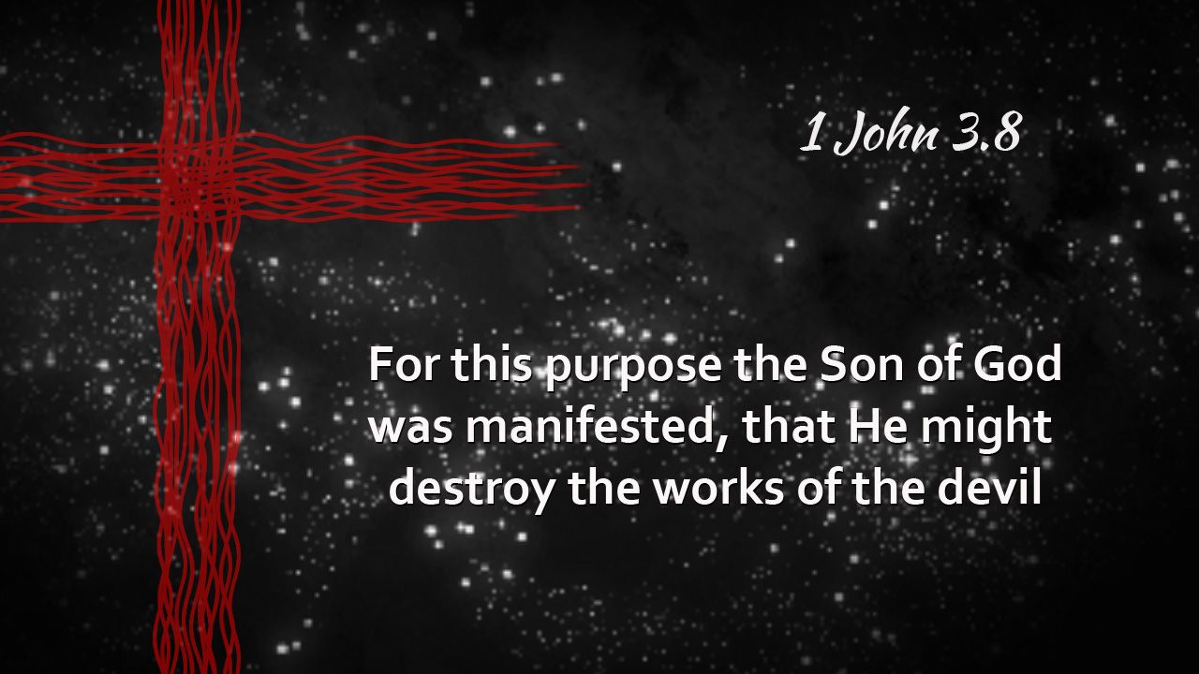

The primary barrier Jesus destroyed, was the wall between mankind and God.

The Jews of Peter’s day thought it was contact with non-Jewish people that would defile them.
But remember what Jesus had taught.

He said that what causes defilement is within a person’s own heart.

In his body, given in sacrifice, Jesus dealt with the true barrier that divides, not Jew from Gentile, but all of mankind from God.
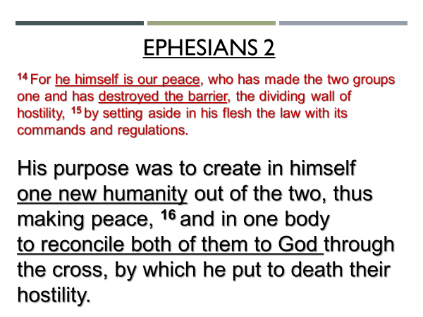
For what purpose did Jesus live, die, rise from the dead and ascend into heaven?
To create in himself…. one new humanity.
The word “new” means “of a new kind, unprecedented, unheard of.”
Jesus did not come to the earth; nor did he sacrifice himself in order to bandage or put a new coat of paint on the human heart.

Look at the wording again.
Jesus’ purpose was what?
“To create in himself…”
Salvation through Jesus is a work of new creation that results in a new kind of human being.

That’s the emphasis of 2 Corinthians 5:17

In what sense are the followers of Jesus a new kind of human being?
Look again at Ephesians 2.
The followers of Jesus are a new kind of human being because we are reconciled to God.
The followers of Jesus are a new kind of human being because we are in an intimate relationship with God. He is our Father, our daddy, and we are his child.

Jesus through the cross, once and for all, dealt with that which had corrupted the human heart and made all of humanity an enemy of God.
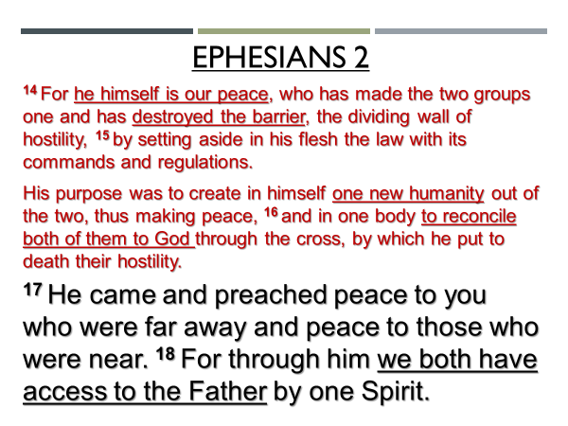
The word of God, which had been preached through Peter and which the Gentiles in Caesarea had received, was the same word that had been preached through the followers of Jesus to the Jews in Jerusalem and Judea and Samaria.

There were and they are not different gospels for different people.

There is only one-way home to God.
There is only one way for the sin committed by our corrupted hearts to be forgiven.
There is only one way to experience the life of the ages that brings peace between God and a person.

There is salvation in no one else but Jesus.
There is no other name under heaven given to mankind by which a person can be saved.

Jesus is the Savior of the world.
Through him and by faith in him God is creating one new humanity, out of all nations; from all tribes; from all people groups; from all languages.

And what God has been doing these last 2000 years, began… in Caesarea, through a Jewish fisherman, and with a Roman soldier, a Gentile man, named Cornelius and the members of his household who put their faith in Jesus.

What does this impress upon us?

The heart of God is for all the people of this world.
When Peter walked his critics through the events that had transpired, they were left in awe and praised God, saying, “So then, even to Gentiles God has granted repentance that leads to life.”

Salvation is not earned.
Men and women are saved by grace through faith.

You and I need to remind one another, again and again, that, God so loved the world that he gave his one and only Son that whosoever believes in him should not perish but have everlasting life.

As one pastor in our region recently said, “God is interested in; God pursues after people who have no interest in him.”
This is what Peter preached to Cornelius.

Jesus, by his Spirit, compels you and I to spend our lives for the sake of his mission – doing good and proclaiming the good news of the gospel.
God is not content to leave humanity under the power of the devil.
God promises to be with his church in the rescue of men and women

We are here in Sooke, for such a time as this… for the people who don’t yet know Jesus.

My experience with the death of my dad.
What matters when death comes near?
Not our money; not our achievements.
There is only one thing that matters.
It’s not that we had strong faith in God.
But that we have faith in God’s strong Savior.

The question asked of my dad – have you kept the faith?

Reconciliation to God is freely given through faith in our precious Lord Jesus – who is the Peacemaker; the Rescuer.

In the words of the OT prophet, we are not to despise the day of small things. See Zechariah 4:10.

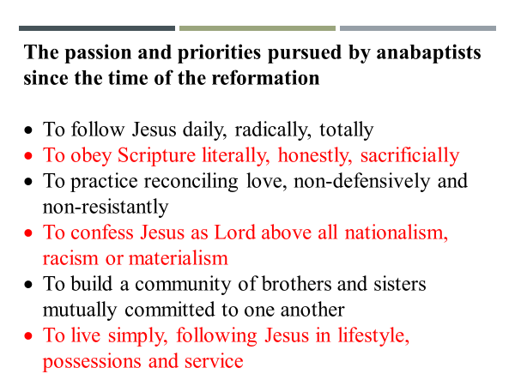

Peter followed Jesus – daily, radically and totally.
We earlier sang, we lay our lives down – we choose his will; his way; always.
This is why Peter journeyed from Joppa to Caesarea to meet with one man and his family.

Did Peter know this encounter would be the bridgehead that would initiate a movement of God that over the centuries to follow, would rescue hundreds of millions of men and women from the dominion of darkness and bring them into the kingdom of God?

Of course, he didn’t.
But neither will we know the full scope of our efforts for Jesus.
Grace Gardens
Big House Breakfast
SYNC Youth
KidZone
Alpha
Colombia Mission

In everything we do we practice and announce the reconciling love of Jesus, walking through the doors God opens.
This is the why that energizes us.

“Who was I to think that I could stand in God’s way?”

I wonder if Peter remembered Gamaliel’s advice to the Sanhedrin in Acts 5:39 – if this is from God, you will not be able to stop these men, but will only find yourself fighting against God.

In what way did the Peacemaker bring us peace?

Humans instinctively build walls.
Some with good cause.
We fence our yards; we put doors with locks on our homes.
We build walls on borders.

Humans instinctively are suspicious of those who are different – whatever those differences would be – in clothing, food, music, art, architecture, business, etc.

The Jews in Peter’s day had built a wall.
Let me explain.

The exile.
The commitment upon return to live distinctively for the glory of God.
The slow drift to the position stated by Peter to Cornelius – 10:28: “It is against our law for a Jew to associate with or visit a Gentile.”

This wall of separation was not God’s law, nor his will.
God had told Abraham that all peoples on earth would be blessed through him – see Genesis 12:3.

Through the prophet Isaiah God had restated to the Jews their purpose.

How could one be a light for the nations, without contact?
How could one bring God’s salvation to the ends of the earth if there was no association with the peoples of the earth?

What happened in Caesarea was unplanned.
What I mean by that is that though Peter had gone on a ministry road trip to Lydda and then to Joppa to visit and encourage fellow followers of Jesus, every indication is that he had no plan to share the gospel with non-Jews; let alone to visit or to stay with Gentile people.

Before we answer the question of why chapter 11 repeats the details of chapter 10… I need to point out of you… 9:43: “Peter stayed in Joppa for some time with a tanner named Simon.”

Why is this statement so significant?
“The tanning process produces a terrible odor….Skins would typically arrive at the tannery dried, stiff and dirty…A tanner would soak the skins in water to clean and soften them. Then they would pound and scour the skin to remove any remaining flesh and fat.

Next, the tanner…would soak the skin in urine, painting it with an alkaline lime mixture, and then dip it in a salt solution in order to loosen the hair fibers so that they could be scraped off with a knife.

After the hair was removed, the tanner would pound animal dung into the skin or soak the skin in a solution of animal brains…working, kneading the skin until it became supple.

Do you remember how Jesus was often criticized for associating with or touching people who were considered unclean or defiled?

According to Jewish law anyone who handled or came in contact with animal carcasses became ritually unclean. (see Leviticus 11:39-40)
What does this tell us about Peter that in staying at a tanner’s house he risked such defilement?

1. In spite of the fact that God had used him in performing an extraordinary miracle, it’s obvious, Peter wasn’t seeking fame or glory…because if he was, he would have upgraded his accommodation.
2. In staying with Simon, Peter chose to associate with the kind of people many Jews found repulsive.

This little detail shows us how much Jesus had impacted the life of Peter.

I also think it hints at how the God the Spirit was at work in Peter, building humility in him, making him ready for what was to come next.

With God nothing is ever wasted.

What happened in Caesarea was a milestone event…
This was the moment it began - the preaching of the Gospel of the kingdom of God to non-Jews.

And where was Peter when he received the revelation that God considers nobody ‘impure’ or ‘unclean’? He was, as a Jewish man, in…one of the most unclean places he could have been…at a Jewish tanner’s house, with the pungent odor of animal skins and urine wafting in the air.

It certainly was not the kind of place most would go to seek a “word from the Lord.””
http://www.meetingplace.church/blog//the-widow-the-tanner

It is difficult for you and I who are so far removed from this incident, to imagine how shocking it was for believers in Jerusalem when they heard what Peter had done.

I believe this is why the things that happened in Acts 10, are recounted again in Acts 11.

For God-fearing Jews, non-association was not a suggestion.
In Peter’s own words – “It is against our law for a Jew to associate with or to visit a Gentile.”

Non-association was a binding law upon Jewish people.
It was a law that divided the world into Jews and non-Jews with limited interaction between the two groups.

If the followers of Jesus had continued to obey this law, it would have confined the gospel within the borders of national Israel.

Six hundred years, the Jews of that day had behaved no differently than people who didn’t know God, although the LORD had again and again, through his prophets, urged his people to turn away from their sin and to turn back to him.

Finally, for the sake of his name, God was compelled to discipline the Jewish people, allowing the armies of the Assyrian and then the Babylonian nation, to conquer and exile the people of Israel for seventy long years.

When the spiritually revived survivors of the exile returned home, they committed themselves to live their lives separated to God.
In the past the people of Israel had been led into idol worship through inter-marriage with the peoples of the nations that surrounded them.
The returning exiles covenanted to not give their children in marriage to those who were not in relationship with the LORD their God.

In the centuries that followed, what was a good priority and practice, was gradually replaced with a law that forbade not just marriage, but contact with anyone who was not Jewish.

This law moved the Jewish people further and further away from the purposes God had intended for them, which was to be, Isaiah 49:6,
“A light for the Gentiles, [in order] that [they might] may bring [the message of God’s] salvation to the ends of the earth.”

They couldn’t be a light without contact.
They couldn’t bring God’s salvation to the ends of the earth if they had no association with the peoples of the earth!

When Jesus was on earth, he had deliberately challenged this rule of non-association.
A criticism frequently leveled against Jesus was this:
Matthew 9:11: Why does he eat with tax collectors and sinners?
Luke 15:2: This man welcomes sinners and eats with them.
Luke 19:7: He has gone to be the guest of a sinner.

Why did Jesus associate with “sinners?”
Because he knew there could be no influence without contact.

Jesus associated with “sinners” because he wanted to model for his followers
what it would look like for them to function as light in the world (Matthew 5); to be a city within a city.

Remember what Jesus had said in Matthew 9:17?
“You can’t pour new wine into old wineskins. If you do the skins will burst and the wine will run out and the wineskins will be ruined. No, you pour new wine into new wineskins…”

This reality, which Jesus had spoken of years earlier, was now confronting the believers in Jerusalem.
What had been a great sounding truth principle, “new wine into new wineskins,” now challenged their long-held assumptions and practices.

The law of non-association was the old wineskin.
The gospel of Jesus was the new wine.
And it was impossible for the new wine to fit in the old wineskin!

Replacing old wine skins was not a painless exercise for the early church.
Nor is it still whenever the gospel challenges our presuppositions.

Acts 11 teaches us how the reconciling gospel of Jesus, with the enabling of God’s Spirit resolved an issue that would not only have divided the church but would have stalled the message of Jesus being taken to the ends of the earth.

Because the events in Caesarea had been unexpected, and because the news of what had happened was second and third, maybe even fourth and fifth hand news, it had been misunderstood.

It’s interesting, that nobody asked Peter, “Tell us why you went into the home of a Gentile?”
In the minds of those criticizing, there was no conceivable reason why
any devout Jew would ever do so.

Often a person expressing negative criticism does not have the whole story
of why someone did what they did or said what they said.
When there is incomplete or faulty information, it is so easy for the person doing the criticizing, to assign motive.

That’s what happened to Peter.
A natural response would have been for Peter to push back; or to break relationship.

But what does the passage say?
Look at v.4 – Peter began and explained everything to them precisely as it had happened…

Peter acted like the One he followed.
He responded peaceably.
He practiced what Paul would later write to the Colossian church as the right way for believers to speak: 4:6: Let your conversation be brimming with grace…so that you will rightly respond to everyone.

Led by God’s Spirit, Peter carefully and with great detail walked people through the events as they had happened.
Peter provided for those criticizing him the larger context which was important for them to have if they too were to adjust their beliefs and practices and bring them in line with what God was doing.

Read verses 5-17.

What was the result of Peter’s explanation?
Look at v.18a – …they had no further objections.
But there was more.
Look at v.18b – and [they] praised God, saying, ‘So then, God has granted even the Gentiles repentance unto life.’

Peter’s precise and grace-filled explanation of what had happened, allowed the believers in Jerusalem to embrace the new thing God was doing.

It isn’t enough for a person entrusted with leadership to claim, “God told me.’

When it comes to the life we share; and the activities and ministries we partner in together, ‘trust me, I know what I’m doing,’ is not how we build confidence in God in others.

As a faith community, when it comes to decisions, or changes in ministry direction, etc., those entrusted with leadership are to walk the church family
or the ministry team through the specifics.

When Peter carefully detailed what had happened, his explanation was used to realign the issue.
It changed from being about what Peter had done, to what God had chosen to do.

That’s how this passage speaks to those entrusted with leadership.
This is the kind of leadership your leaders here at SBC are committed to practicing.

But there is another application in this passage.

Instead of filling in the missing pieces ourselves of why someone did what they did or why we don’t think such and such is of God, the Spirit of grace will always lead the followers of Jesus to engage in a conversation with one another for the purpose of understanding.

This is how we stay in step with the Spirit.
This is how we build strong relationships between one another.

What do you do if you’ve experienced negative criticism from others?
If you permit it, the judgment of others can quench your zeal for God, or make you afraid to step out in faith and follow God boldly.

If that has happened to you, I want to encourage this morning
to confess to God your fear of others
and to then turn away from that fear.
I also want to encourage you to recommit yourself to being
God’s woman or God’s man
and follow him and do what he is prompting you to do.

If you’ve been guilty of negatively criticizing another person,
I encourage you this morning to repent and turn away from that sin.
Satan is identified as the accuser of believers.
You must turn away from helping him.
If the person you’ve criticized knows what you’ve said about them,
then part of your turning away from sin
is to confess to them that what you said about them was wrong
and ask their forgiveness.

Time of Silent Prayer

Tie in the closing song to the response

Our closing song focuses us again on God’s great love
that was expressed for us through Jesus
when he died on the cross for us.

As we’ve experienced his forgiveness, his love,
we in turn extend forgiveness and love to one another.

The Blessing

Colossians 4:6: Let your conversation be always full of grace, seasoned with salt, so that you may know how to respond to everyone.

May your relationship with God be so open and transparent that there is nothing in you
that holds back his Spirit from being fully expressed in you.

And if there is something in you
that dismays the Spirit of God,
may you experience this morning,
the blessing of repentance,
cleansing from and forgiveness of sin.

In this way, may you know the blessing of your life
being full of God’s grace.

And as God’s grace overflows in your life,
may you know the blessing of that grace
transforming your speech
and your relationships with others.

