Palm Sunday 2020 April 5, 2020

Matthew 21:1-17/Luke 19:29-46
As they approached Jerusalem and came to Bethphage and Bethany on the Mount of Olives, Jesus sent two disciples, ² saying to them, “Go to the village ahead of you, and at once you will find a donkey tied there, with her colt by her. Untie them and bring them to me. ³ If anyone says anything to you, say that the Lord needs them, and he will send them right away.”

Those who were sent ahead went and found it just as he had told them. As they were untying the colt, its owners asked them, “Why are you untying the colt?”
They replied, “The Lord needs it.”

⁴ This took place to fulfill what was spoken through the prophet: ⁵ “Say to Daughter Zion, ‘See, your king comes to you, gentle and riding on a donkey, and on a colt, the foal of a donkey.’”

⁶ The disciples went and did as Jesus had instructed them. ⁷ They brought the donkey and the colt and placed their cloaks on them for Jesus to sit on. ⁸ A very large crowd spread their cloaks on the road, while others cut branches from the trees and spread them on the road.

When he came near the place where the road goes down the Mount of Olives, the whole crowd of disciples began joyfully to praise God in loud voices for all the miracles they had seen: “Hosanna to the Son of David!” “Blessed is he who comes in the name of the Lord!” “Hosanna in the highest heaven!” “Peace in heaven and glory in the highest!” Blessed is the coming kingdom of our father David! (Mark 11:10)

Some of the Pharisees in the crowd said to Jesus, “Teacher, rebuke your disciples!” “I tell you,” he replied, “if they keep quiet, the stones will cry out.”
As he approached Jerusalem and saw the city, he wept over it and said, “If you, even you, had only known on this day what would bring you peace—but now it is hidden from your eyes. The days will come upon you when your enemies will build an embankment against you and encircle you and hem you in on every side. ⁴⁴ They will dash you to the ground, you and the children within your walls. They will not leave one stone on another, because you did not recognize the time of God’s coming to you.”

¹⁰ When Jesus entered Jerusalem, the whole city was stirred and asked, “Who is this?” ¹¹ The crowds answered, “This is Jesus, the prophet from Nazareth in Galilee.”

¹² Jesus entered the temple courts and drove out all who were buying and selling there. He overturned the tables of the money changers and the benches of those selling doves. ¹³ “It is written,” he said to them, “‘My house will be called a house of prayer,’ but you are making it ‘a den of robbers.’”

¹⁴ The blind and the lame came to him at the temple, and he healed them. ¹⁵ But when the chief priests and the teachers of the law saw the wonderful things he did and the children shouting in the temple courts, “Hosanna to the Son of David,” they were indignant.

¹⁶ “Do you hear what these children are saying?” they asked him.
“Yes,” replied Jesus, “have you never read, “‘From the lips of children and infants you, Lord, have called forth your praise’?”

¹⁷ And he left them and went out of the city to Bethany, where he spent the night.

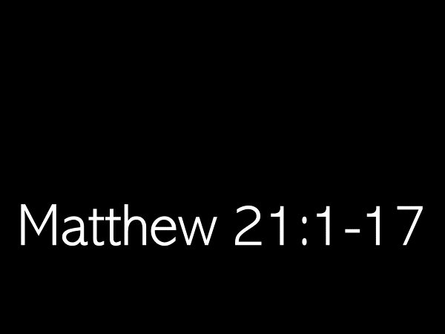
The story of Palm Sunday is one we retell every year, along with the events of Jesus’ last week.
The four gospels tell us that Jesus is the King.
The details of his last week on earth reveal the kind of king Jesus is.

As Jesiah read for us, a great crowd accompanied Jesus as he rode into Jerusalem on the day, we call Palm Sunday.
John in his gospel, explains who made up this great crowd.
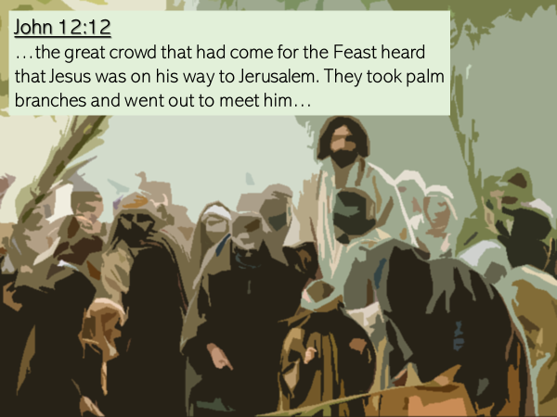
But what was it on that particular day that moved so many to go out to meet Jesus and accompany him into the city?
Again, it is John in his gospel who explains.
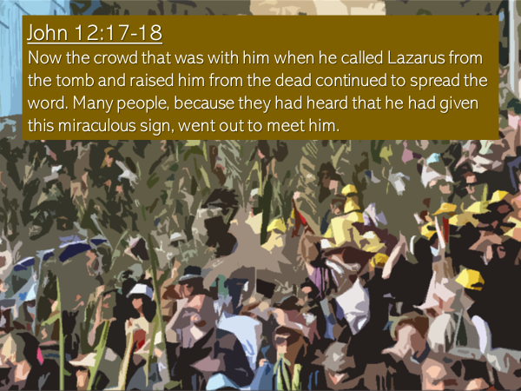
Those who witnessed the resurrection of Lazarus couldn’t help but talk of what they had seen… and when word, spread like wildfire through Jerusalem, that Jesus was coming, both followers and the curious had to see him, meet him, be with him…because…it is no ordinary person who raises someone from the dead!!!

How many people met Jesus on that day? How many accompanied him?
We are not told numbers.
But John in his gospel did record the reaction of the Pharisees when they saw the crowd that day… and the sheer quantity of people dismayed them!

This is what they said to one another:
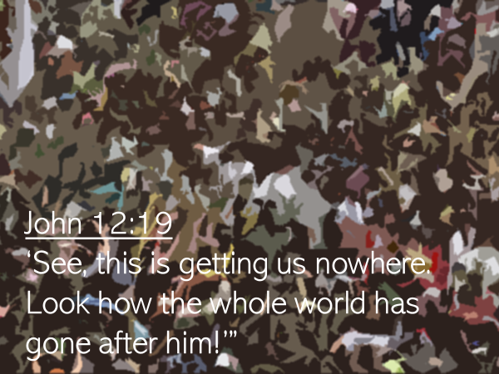

Those who accompanied Jesus joyfully praised God in loud voices for the miracles Jesus had done in their presence.
Their shouts of praise were saturated with messianic phrases.

And Matthew made sure that his readers understood, the prophetic significance of what Jesus did when he rode into Jerusalem upon a donkey and on a colt, the foal of a donkey.

Look again at verse 4: “This took place to fulfill what was spoken through the prophet.”

The prophet which Matthew referred to was Zechariah, who had written 500 years earlier.

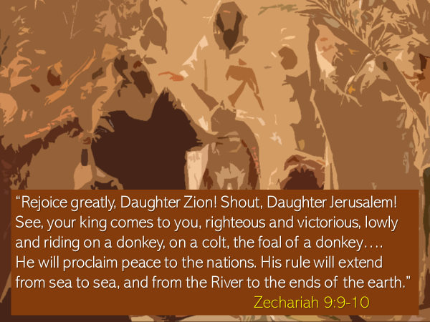
Was Zechariah the first prophet to speak of… a king… who would come to Jerusalem riding on a donkey? A king who would proclaim peace, not only to Jerusalem, but to the ends of the earth?

No, he wasn’t.
This was a theme deeply embedded in the story of Israel.
We need to think back to the time described in the second book of the Bible – Exodus.

It had been Moses who led the nation of Israel out of Egypt.
Then Joshua, had led the nation into the land of Canaan to possess it.
After him, numerous judges over a period of 400 years (Deborah, Gideon, Samson) provided leadership.
The last judge was Samuel.
When Samuel was old, the elders of Israel approached him and said:
“You are old, and your sons do not walk in your ways; now appoint a king to lead us, such as all the other nations have.” 1 Samuel 8:5.

Up until that point Israel had functioned as a theocracy – their King was God.

The request of the elders displeased Samuel.
But God told him:
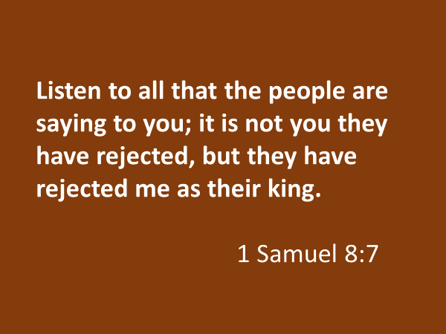

At this point, we need to step back to the book of Genesis…chapter 49… and look at the prophetic word Jacob spoke over each of his twelve sons before he died.

Jacob spoke of his fourth born son, Judah, as being a lion…
And then, in verse 10 he said:
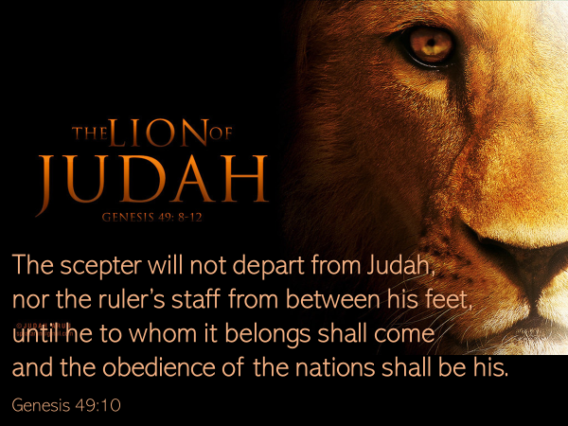
But to his youngest son, Jacob said, Genesis 49:27:
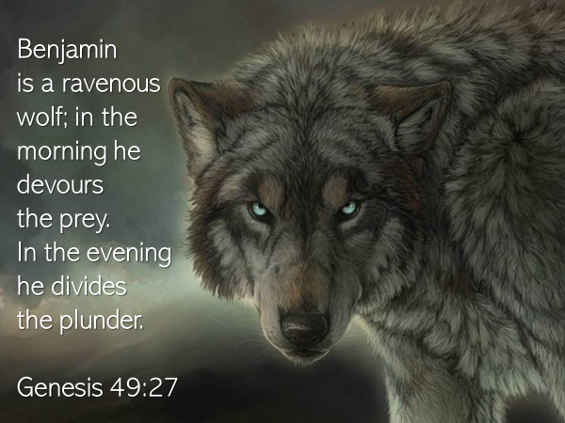
Keep these two distinct prophetic words in mind as we look at who God directed Samuel to anoint as king – it was Saul, the son of Kish.
And what tribe was Saul from?
He was not from the tribe of Judah, but from Benjamin.

Why did God do this?

Timothy Tennent wrote:
Because the request for a king began out of rebellion rather than obedience, the first king was specifically chosen from the tribe of Benjamin.

Why was that?
That Israel might experience the bitterness of soul that comes when one runs ahead of God; when one demands something from God that is not his best or is not the right time to be given.

Samuel endeavored to counsel the people that they would regret this request.
He cautioned them, he warned them, that this king would be like a wolf, this king… would take…

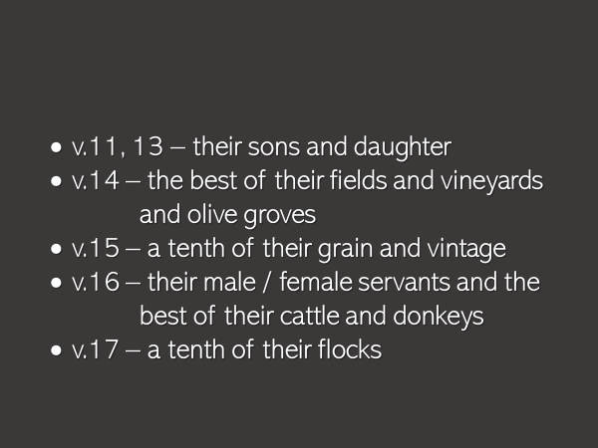
But the people demanded, “We want a king over us. Then we will be like all the other nations, with a king to lead us and to go out before us and fight our battles.” 1 Samuel 8:19-20.

The king, which they demanded, and which they were given, tragically, turned out to be a man who trusted in his own strength and wisdom, rather than the Lord’s…. he was just like the nation who had asked for him.

Because of his disobedience, Saul’s kingship came to a tragic end.
Samuel was sent to Saul with this message from God: Because you have rejected the word of the LORD, he has rejected you as king. 1 Samuel 15:23.

Saul was replaced by David, a young man from…can you guess??…the tribe of Judah.

David too, like Saul, was not a perfect king.
He committed adultery with Bathsheba.
When she became pregnant, David murdered Bathsheba’s husband, who was his best friend… to cover up what he had done.
David had disastrous parenting skills – his own household was a mess.

And yet… God said of David, he is “a man after my own heart.” 1 Samuel 13:14.

David loved God with all of his heart, soul and mind.
But when David failed, as he repeatedly did, he always responded to God’s grace, humbling himself, confessing his sin and turning from it.

Because God’s glory and honor was proven to be David’s priority, God entered into a covenant with David, promising, 2 Samuel 7:
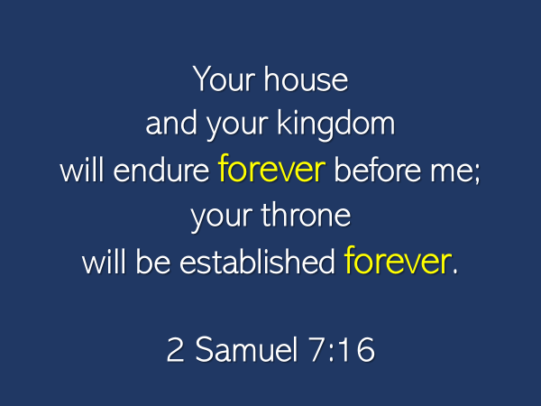

The particulars of this covenant make it clear that David was the intermediate, not the ultimate fulfillment of the prophetic word spoken by Jacob in Genesis 49.
The word “forever” is what confirms this.

David was like a signpost that pointed ahead… to a greater One yet to come… who would be, as Jacob had seen, the Lion of Judah, the King to whom the obedience of the nations belonged.

During the reigns of the 20 kings who followed David… the nation of Judah repeatedly and grievously broke faith with God.
They were led by many kings who were as evil, if not more, than the Amorites who had lived in Canaan before them.

All calls by God to repent were rebuffed.
Finally, the patience of God was exhausted, and he exiled his people to Babylon, bringing to an end the kingdom of David and his throne.

Something even more tragic happened in those days.
In the days of Ezekiel, the presence and the glory of God departed the temple –
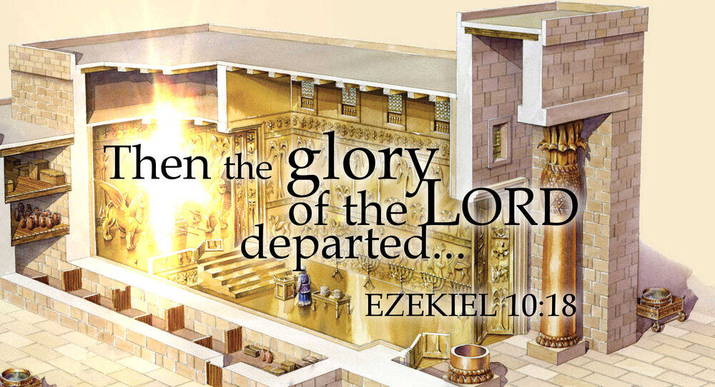

Jeremiah the prophet, a contemporary of Ezekiel, voiced the desperate cry of the people in his day when this happened, 8:19: Is the LORD not in Zion? Is her King no longer there?

Despite their unfaithfulness, and despite his severe discipline, God remained faithful to his people, promising that a time would come when he would bring the exiles back.
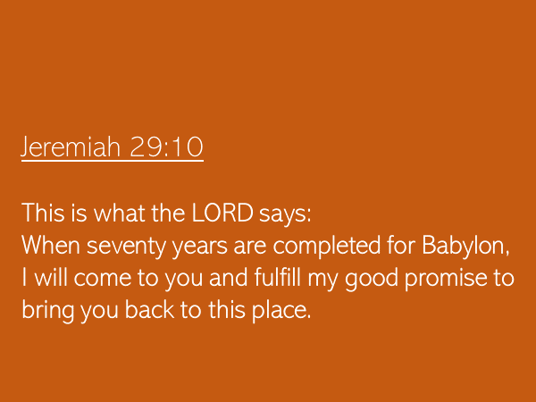
True to God’s word, after 70 years, the exiles began to return home.
As they did so, God promised through the prophet Zechariah that like the exiles, he too would return to Jerusalem.

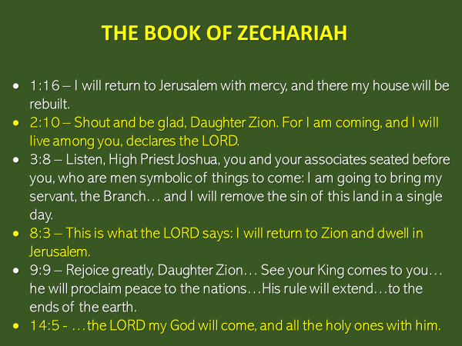
Can you imagine the relief and joy of the exiles when they heard this news?
They took hope and waited, eagerly, expectantly…for the Lord to return; for their King to come and his peace to reign.

But after these promises had been made, years turned into decades, and long decades stretched into centuries, four hundred years to be exact, as the nation waited for the Lord to come.

This was the backdrop to the story of the gospels.
Can you grasp Mary’s shock, when the angel Gabriel told her that what she and her people had waited for so long…. was about to be fulfilled through her?

- the child to be conceived in her by the power of the Holy Spirit was the Son of the Most High
- the LORD God would give to him the throne of his father David
- her child would reign over Jacob’s descendants forever
- his kingdom would never end
- Luke 1:31-33.

Mary’s song of praise in Luke 2 was the overflow of deep gratitude to God and thankfulness for his faithfulness.
Mary was not alone.
Elizabeth shared her joy.

And then there was Simeon.
Can you feel in a some capacity his absolute wonder, when the Holy Spirit moved him to go to the Temple, where he met Mary and Joseph and then held in his arms the eight day old baby Jesus, the one, his heart had longed to see.

Simeon’s praise to God was the overflow of profound gratitude:
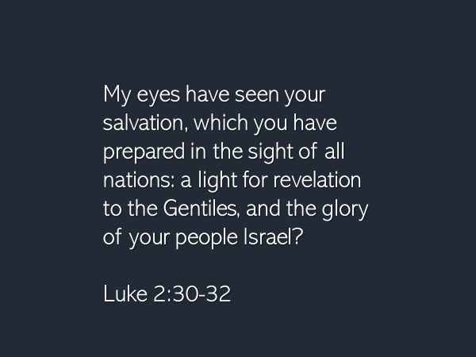
I’ve directed us to Mary and Simeon, in order to help us to appreciate the sheer joy and ecstasy of those who accompanied Jesus as he rode into Jerusalem on the foal of a donkey.
The conviction of… who Jesus was… had been growing.
Many had said of Jesus… who is able to do the things he has done?
And when Jesus raised Lazarus from the dead… many believed…the long wait was over…the King had come… the promise of God had finally been fulfilled.

But what kind of king would he be?
On Good Friday and Easter Sunday, we’ll answer that question of how Jesus brought peace to the nations; how he extended his rule to the ends of the earth, as Zechariah had foretold.

As we finish our study this morning, I do want to make one connection to our lives that comes out of what Jesus said from the Mount of Olives as he looked across to the city of Jerusalem.
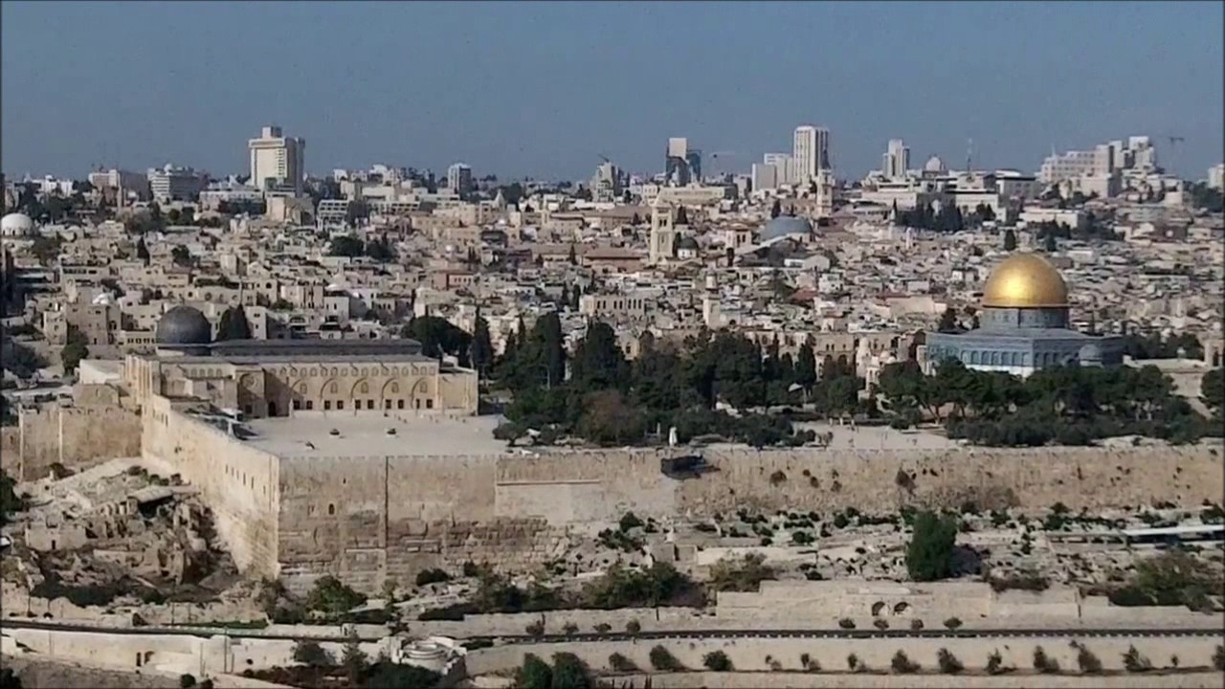

There are many other applications in this passage.
I am certain some of you have already experienced the Spirit of God confirming a particular truth emphasis in your heart.

But this is the one I want to leave with you.
When Jesus saw the city, he wept over it.
How many times did Jesus weep?
Twice that we are told of in the gospels.
The first time, at the tomb of Lazarus before he raised him to life, and the second time, here on the Mount of Olives.

These tears shed by Jesus were not tears of joy.

We are not told why Jesus cried at the tomb of Lazarus.
I think he did so because he knew death was never part of God’s original creation intent.
I believe he groaned in his spirit, “O Father, this is not what we intended. We created them to live, not die.”

And on the Mount of Olives?
What was it that grieved Jesus?
Let’s look at the text again:
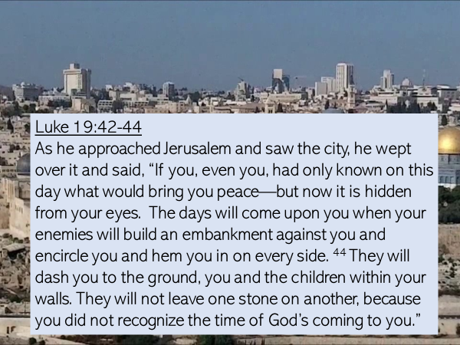

What grieved Jesus was how sin had so hardened the hearts of those who lived in Jerusalem, that in spite of the miracles he had done, in spite of the teachings he had given, in spite of the testimony of those who sang his praise and journeyed with him, the majority of people in Jerusalem, rather than turning to him, turned from him.

Incredible opportunity had been given to them
As Zechariah had foretold, the king had returned.
As Jacob had foretold, the Lion of Judah, had rode into their city.

The greater Son of David, God’s Messiah had been among them – they had seen him and heard his voice.
And they did not receive him.

Jesus wept for the opportunity that had been lost.
He wept for the consequence of sin… that would result.
For as I’ve said, sin always ends in death.

At the hands of the Romans, in 70 AD, death would walk the streets of Jerusalem and annihilate its people and leave its streets and buildings in ruins.
This is what Jesus foresaw and why he wept.

Jesus’ reaction gives us a glimpse into the heart of God.
Jesus came into the world to save – John 3:17.
In the person of Jesus, God has given a great opportunity for all men and women, to come home to him.

Jesus is the Savior of the world.
The peace he proclaims and brings is for every nation, every tribe, every people, every language.

His authority to save, as Zechariah foretold, extends from sea to sea, and to the ends of the earth.

In this lifetime, and only in this lifetime, because of Jesus, your destiny can be changed.
In Jesus there is opportunity for your sins to be forgiven.
In Jesus you can be reconciled to God.

This is the good news.
This is the opportunity of a lifetime.

Now what will you do?
We don’t know how many God-given opportunities we get.
We don’t know if we say no today, if, and when another opportunity will come.

But if you have sensed his pull on your life, if there is an inner conviction that you need to act and come home to God today, then I urge you to act.
God’s word to you is this, “Today, if you hear my voice, come to me.”

Please don’t do as many did on that long-ago day.
Please, receive Jesus… today.
You can speak to him from your heart, right where you are.
Let me help you.

Tell him you are turning away from your way of life that has excluded God.
Ask God to forgive you for the sin you have committed.
And acknowledge to him, whatever sin comes to your mind.

Tell him you are turning your life toward Jesus Christ.
Tell him you trust him and thank him that you are forgiven because Jesus paid your sin debt in full.

Now welcome Jesus into your life – tell him he’s in charge.

If you welcomed Jesus into your life today, I would love to speak with you.
Would you email me so we can arrange a time to talk?
Prayers of the People

- The kindness and severity of God – Romans 11:22
- The confession of Job, 42:2 – you can do all things; no purpose of yours can be thwarted
- Lamentations 3:21-26 – the context is important
- Habakkuk 3:19 – the Sovereign Lord is my strength

Someone on Gospel Coalition wrote in an article today:
“adjust the clock of our soul to God’s timetable – the Lord does what is right and he is always on time.”

Wait quietly – Lamentations
Wait patiently – Habakkuk
Take joy in the God of our salvation

The Blessing

Revelation 22
I am coming soon.

What is the point in Jesus saying this?
Hold on.
Don’t lose hope.
Persevere.
See your faith carry you to the end

Of course we don’t know how this will all end.
But Jesus does.
It will end at his glorious return.
He is coming soon.

Live in light of the blessed hope.

Jesus foresaw the devastation that the armies of Rome would cause to Jerusalem and its people in 70 AD.

But I want to put before this emphasis that comes out

The promise that the king would come, and the hope that promise instilled in the hearts of those who followed God, awaited God’s chosen moment of fulfillment.
And it was a long wait…

It is difficult for us to wait on God.
To trust when it seems he is waited too long.

It is the default of our human nature that we are in a hurry.
We are prone when

Jesus had come to Jerusalem and revealed himself as Israel’s king.
But his coronation would not be like that of other kings.
His throne would be a cross.
His crown would be made of thorns.
His scepter would be a staff used to repeatedly strike his head.
His anointing oil would be spit.
And rather than being dressed in royal clothes he would be stripped and a borrowed scarlet robe thrown over his naked body.

When Jesus entered the city he didn’t go to the Roman garrison and drive the soldiers out.
He didn’t go to the palace of Pilate and send him back to Rome.
Jesus was a different kind of king.
And we shall see on Good Friday and Easter Sunday just how different he was.

On that same day, when the religious leaders attempted to get him to stop his disciples; and then later in the temple to stop the children from praising him, he refused.
When all of Jerusalem was stirred and people were asking, “Who is this?” Jesus did not stop his followers from answering.
When he came into the temple courts, with great authority he drove out the money changers and the dove sellers, as if the temple was his, which it was.
When the lame and blind came to the temple, he healed them.

Can you sense the ecstasy of those who shouted his praise?
Can you feel their excitement – they had lived to see the day when their king had returned?

And while it was day of unparalleled joy for those who lined the road from the Mount of Olives into the city,
What had been promised was
In choosing to ride into Jerusalem on a donkey, he declared, he was Israel’s king.
In going to the temple courts and driving out the buyers and sellers who had turned his house into a market, he revealed himself as the king who had returned to Jerusalem and had come to take his rightful place.

Many that day welcomed him; they shouted out his praise, confessing he was their Messiah.

Jesus, who up until this point, had always cautioned people he healed to not say who he was
When Jesus was brought to him, Pilate straight out asked: Are you the king of the Jews? John 18:33

Jesus answered him: You are right in saying I am a king. In fact, for this reason I was born, and for this reason I came into the world, to testify to the truth. Everyone on the side of truth listen to me… [But] my kingdom is not of this world. If it were, my servants would fight to prevent my arrest by the Jewish leaders. But now my kingdom is from another place. John 18: 37b, 36.

If God is who says he is: “…the great King over all the earth,” Psalm 47:2
why was it necessary for God in Jesus to be born into this world?

At the fall of the human race, Satan usurped and then perverted the role God had entrusted to humanity…. to be the presence of God on the earth, caring for the creation as God himself would have if he were physically present.

The Bible describes the usurper as “the god of this age,” 2 Corinthians 4:4.
1 John 5:19 says, “that the whole world is under the control of the evil one,” and that he, 2 Timothy 2:26, “… has taken people captive to do his will.”

As King Jesus had come into the world to depose the evil one and to destroy his work as 1 John 3:8a says.

He did so by “giving his life as a ransom for many.” Matthew 20:28

Paul would later write to young Timothy and echo these words of Jesus, saying, “For there is one God and one mediator between God and mankind, the man Christ Jesus, who gave himself as a ransom for all people.” 1 Timothy 2:6

With this as our background, let’s interact with the story of Palm Sunday.
For though it is, like Christmas, a story retold each year, it is a story that never gets old, for it is a story that speaks of the shocking and radical lengths to which God in Jesus went in order to rescue.

After Jesus was born in Bethlehem, Magi from the east came to Jerusalem, and asked, “Where is the one who has been born king of the Jews?” Matthew 2:2

Many hundreds of years earlier, it was through Daniel, who had been appointed Chief of the Magi, that the Magi had learned of the prophecy made in Numbers 24:17: “I see him, but not now; I behold him, but not near. A star will come out of Jacob; a scepter will rise out of Israel.”

It was the teachers of the law in Jerusalem that answered the Magi, by directing them to Micah the prophet, who had foretold where this ruler would be born, 5:2: But you, Bethlehem, in the land of Judah, though you are small among the clans of Judah, out of you will come a ruler who will be the shepherd of my people Israel, whose origins are from of old, from ancient times. Matthew 2:6

The hope of the Messiah’s coming filled the hearts of many who lived in that day.
But many misunderstood the kind of king the Messiah would be.
They hadn’t perceived from the OT Scriptures that the Messiah would come to the earth, not once, but twice.

After Jesus had miraculously fed 5000 men plus women and children using only five loaves of bread and two small fish, the people began to say among themselves, “Surely this is the Prophet who is to come into the world.” John 6:14.

There and then a plan began to take shape in the minds of some; a plan which Jesus was aware of.
John writes of this in his gospel, 6:15: Jesus, knowing that they intended to come and make him king by force, withdrew again to a mountain by himself.

